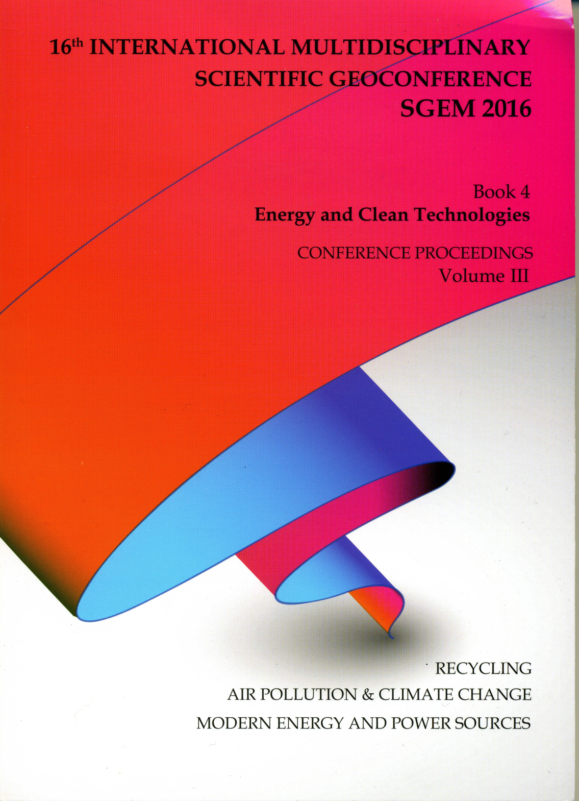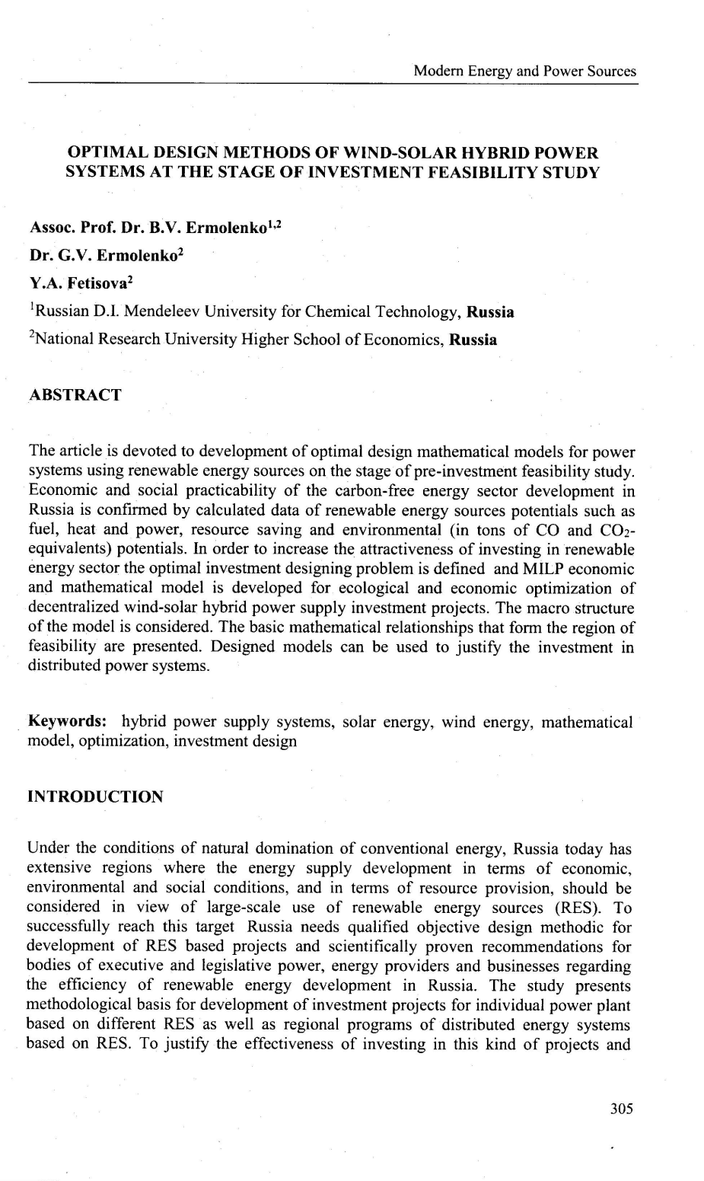
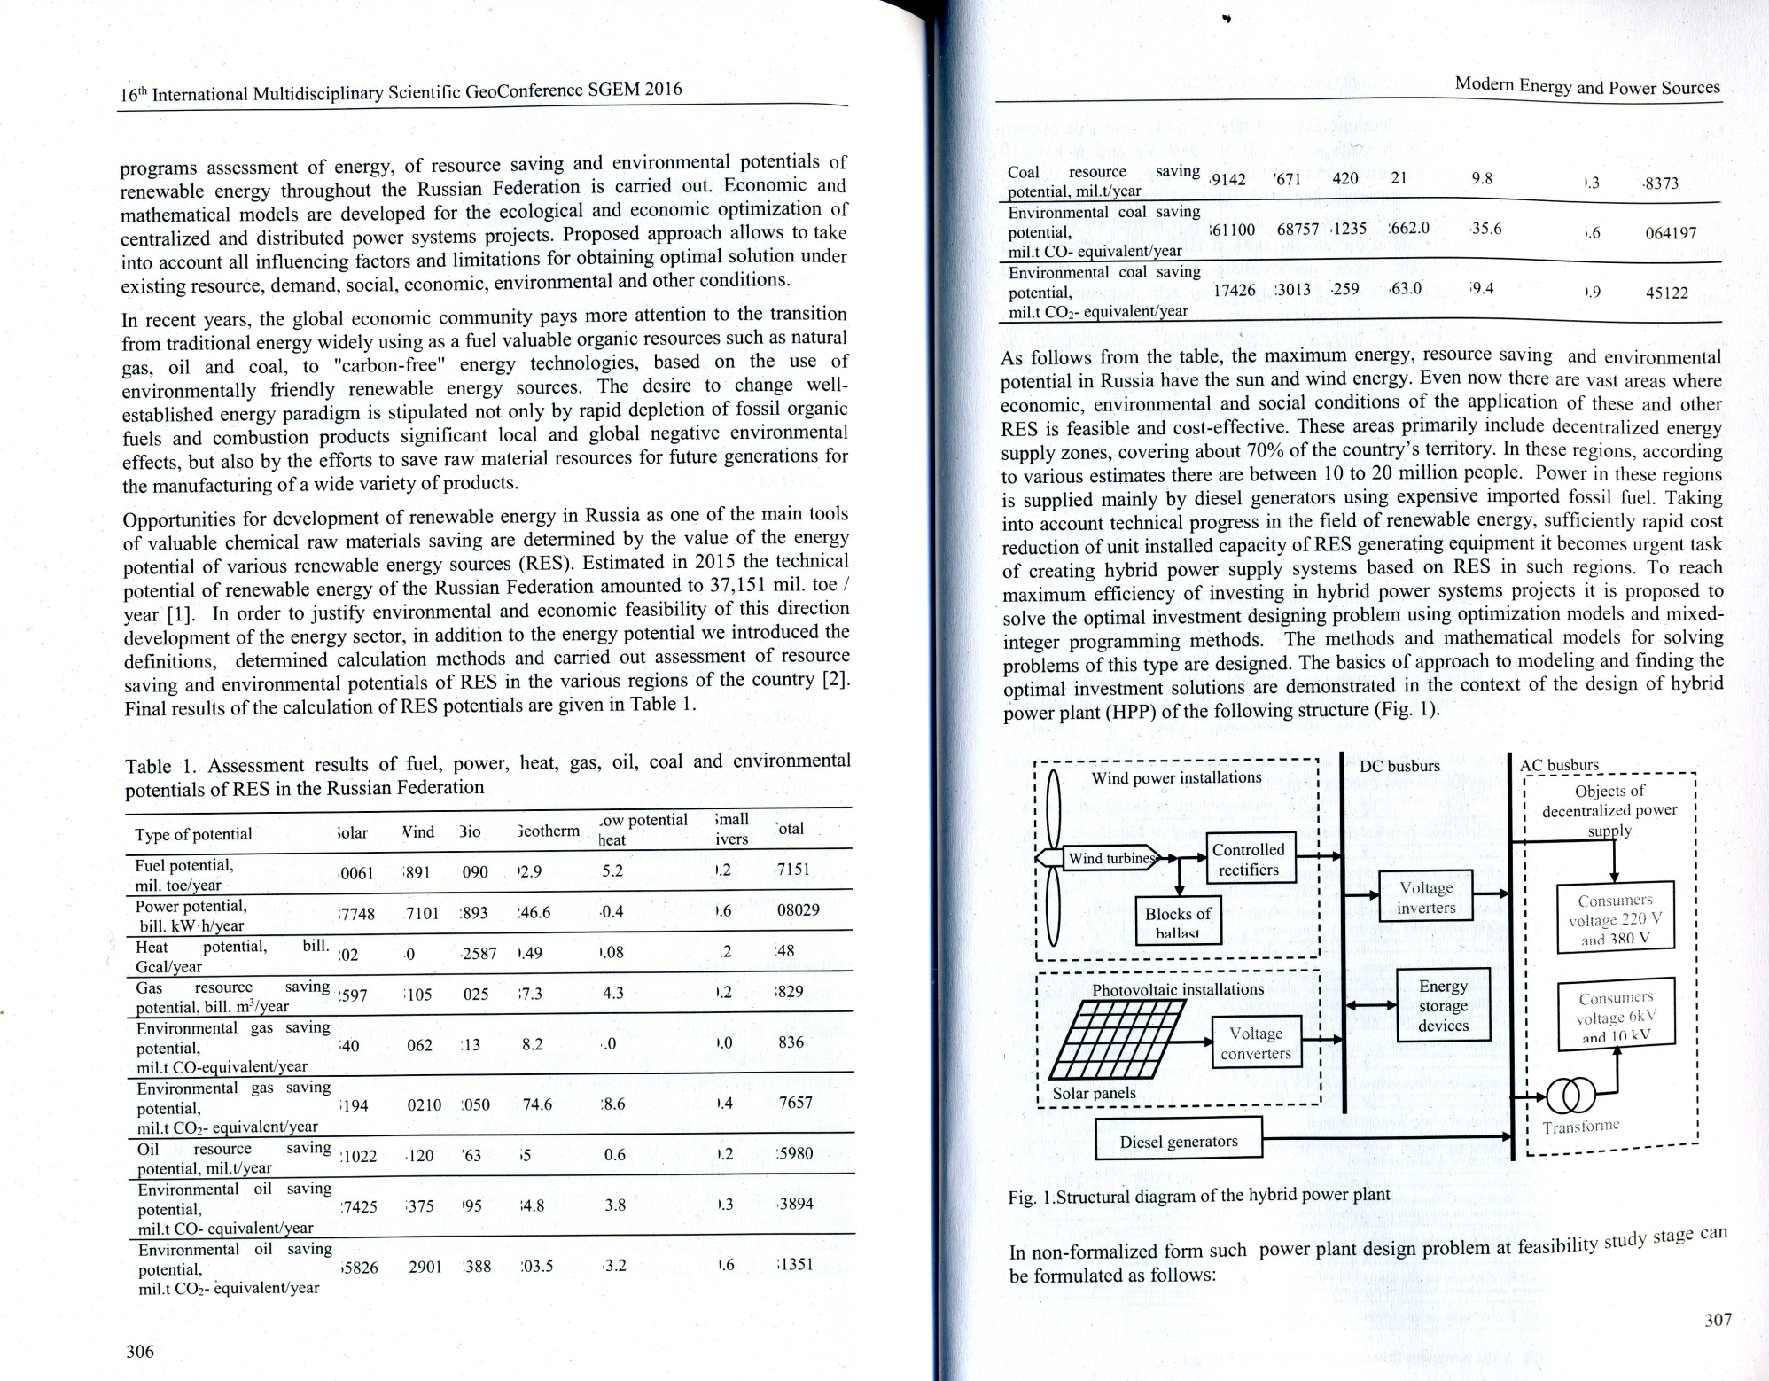
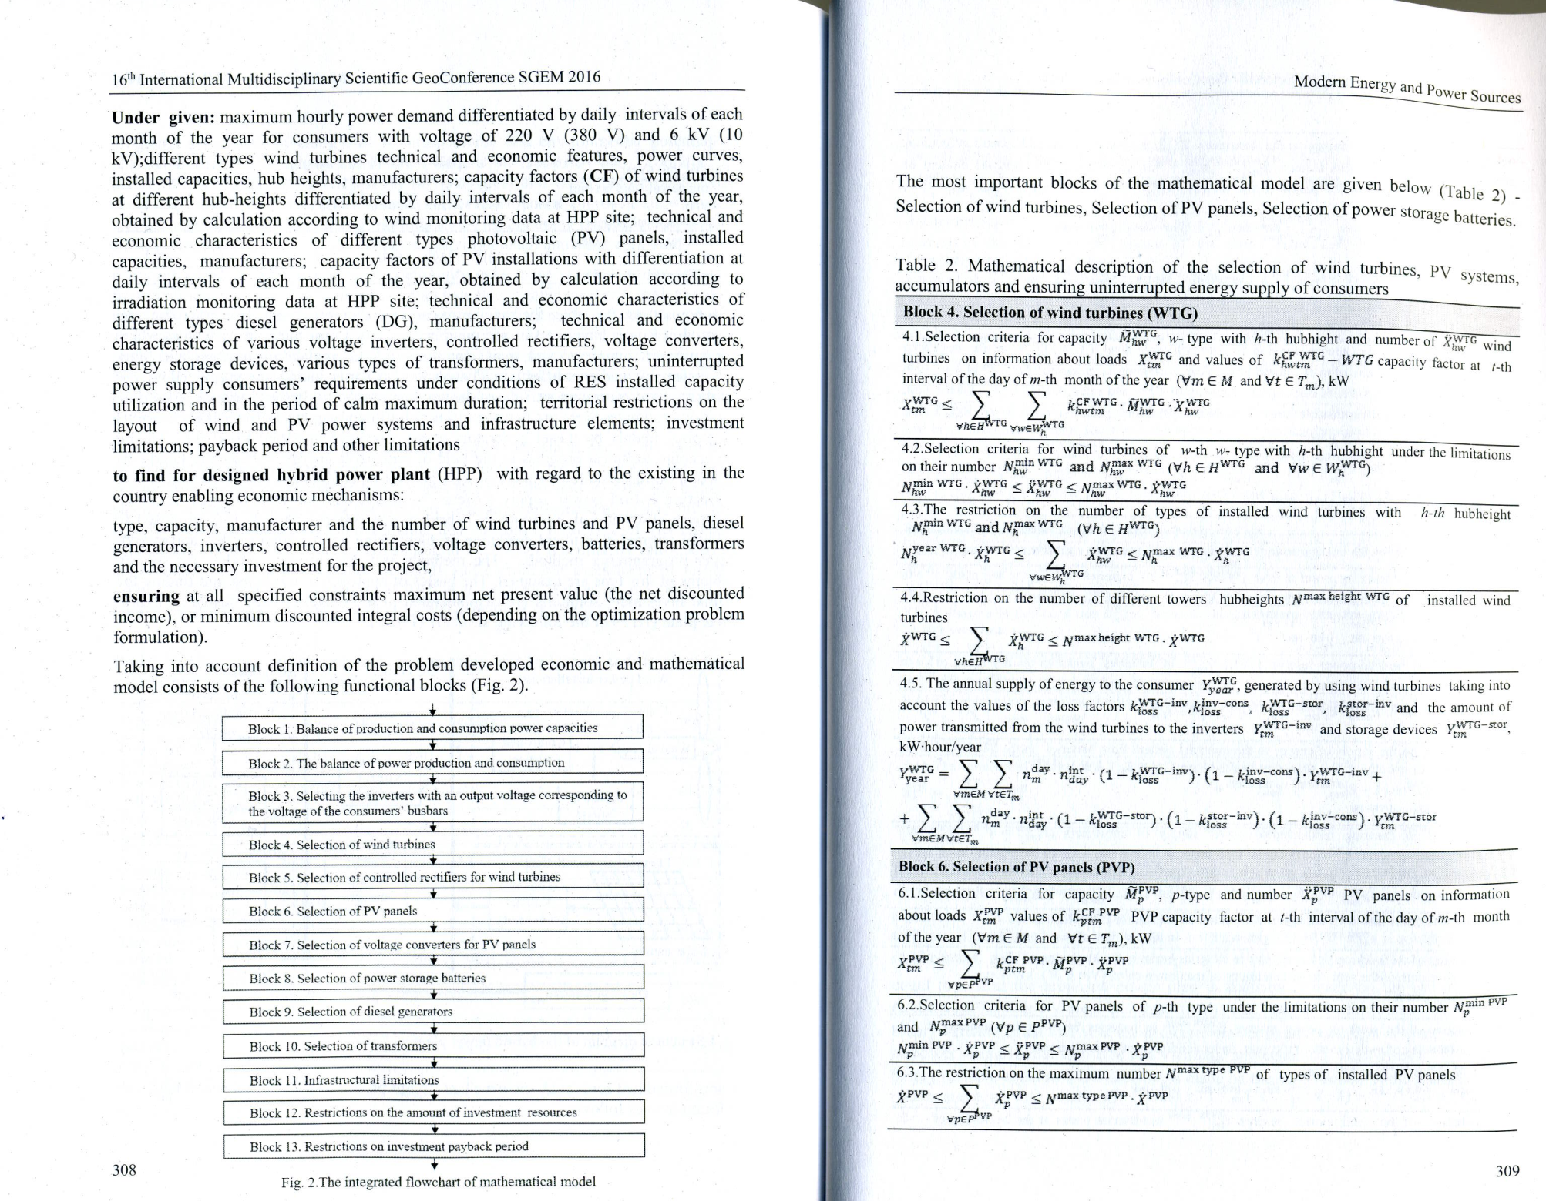
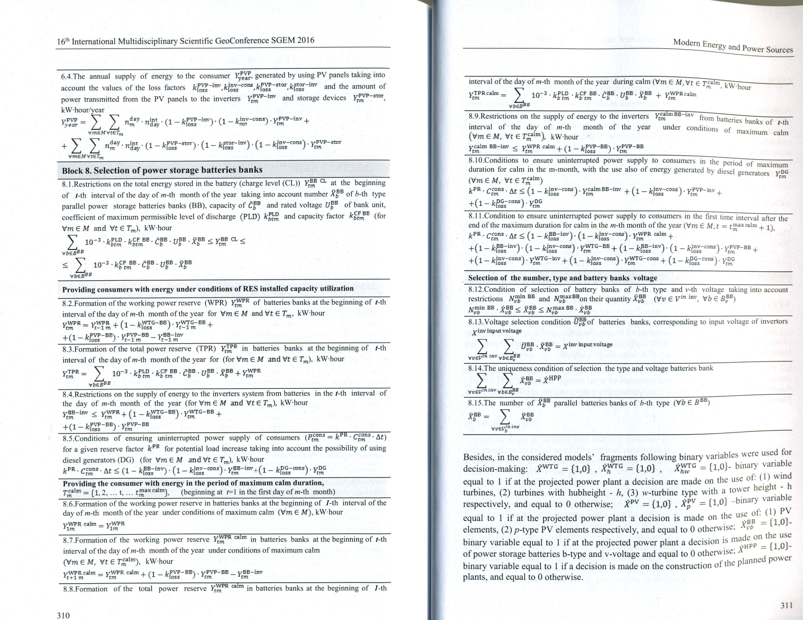
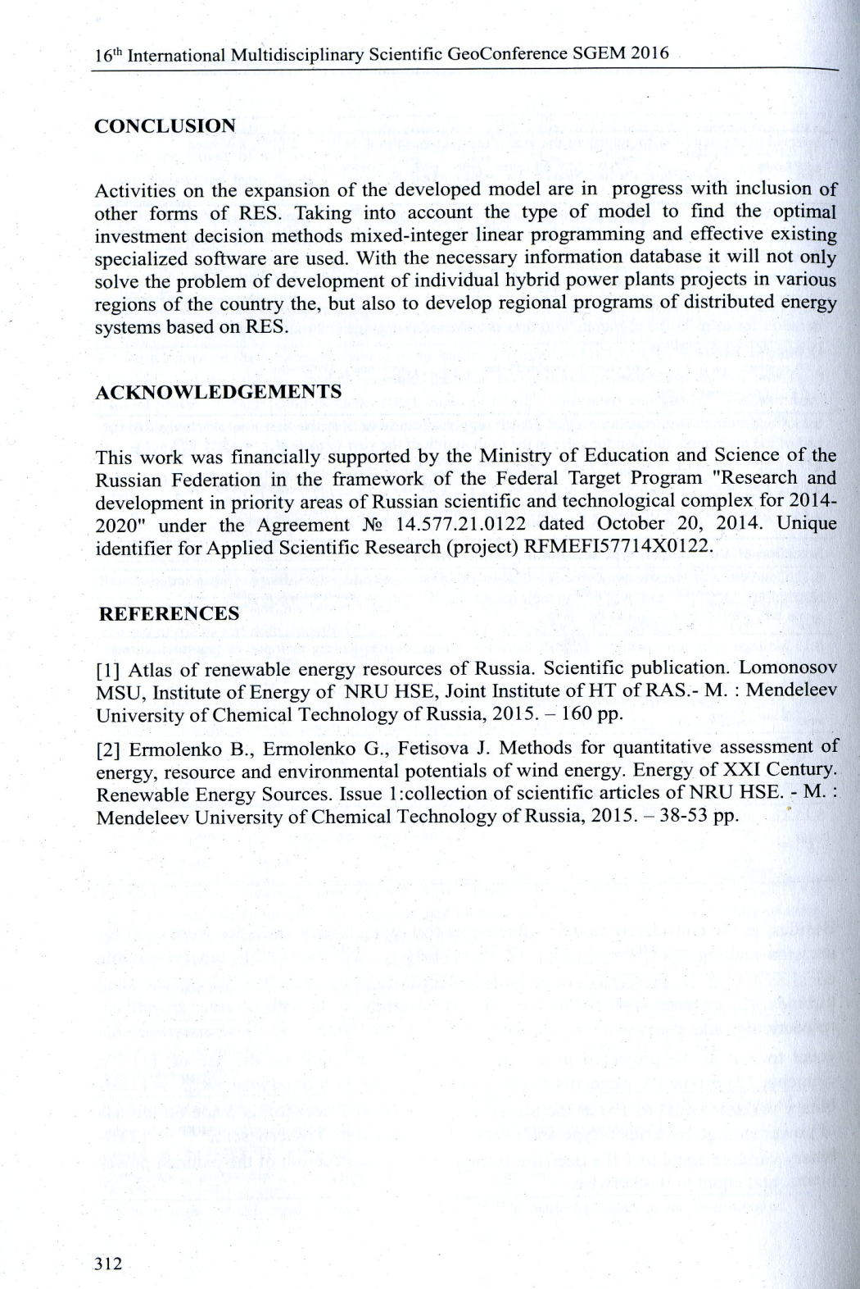

Impact factor
All submitted papers are peer-reviewed and published in a conference proceedings (hard copy format), which is given to every participant at the conference venue in the day of his registration. While submitting his paper, every authors is obliged to read and confirm the Publishing Agreement - a policy treating the originality of the submitted article, copyright terms & conditions and etc.
The scientific impact factor of the events are assured by the long-established and strong connections with most of the well-known indexing databases. It is our great pride that SGEM Conference Proceedings are indexed into the most popular and scientifically strong databases:
- SGEM title is indexed in Thomson Reuters, ISI Web of Knowledge, ISI Web of Science since 2008.
- SGEM proceedings are part of the collection of the ELSEVIER Products - SCOPUS since 2005.
- All SGEM papers since 2006 are also indexed by ProQuest, EBSCO as well as by many distinguished libraries as the British Library and other scientific institutions.

